The goal of our investigation was to provide some guidance and recommendation on how Big Mountain Resort can increase their revenues by exploring a range of changes that will potentially either cut costs without undermining the ticket price or will support an even higher ticket price. After cleaning, analyzing, and assessing the Big Mountain Resort data, I identified top facility features that may impact ticket price and revenue gain.

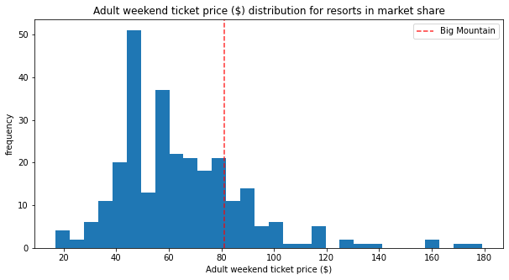

Big Mountain currently charges $81.00 for the ticket price. The calculated expected Big Mountain Ticket Price based on the model is $95.87 with a MAE of $10.39 if the ticket price was supported in the marketplace by Big Mountain’s facilities. The result suggested that there is a sizable room for an increase in ticket price as it the data seems to suggest that our resort might be undercharging. Our model was performed to help determine how each of facility feature may support a given ticket price. With that in mind, I ran simulations that explored four potential scenario options as suggested by leadership which include:

1. Permanently closing up to 10 of the least used runs.
2. Increase the vertical drop by adding a run to a point 150 feet lower down but requiring the installation of an additional chair lift to bring skiers back up, without additional snow making coverage.
3. Same as number 2, but adding 2 acres of snow making cover.
4. Increase the longest run by 0.2 mile to boast 3.5 miles length, requiring an additional snow making coverage of 4 acres.

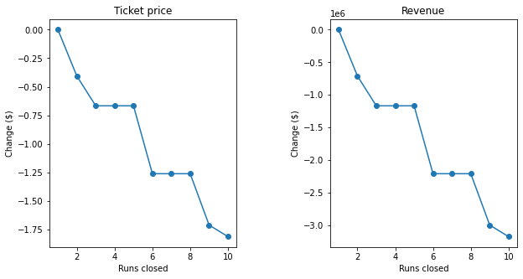

After performing the model simulations, we concluded scenario 1 and 2 for further consideration. I recommend that Big Mountain can test closing down at least 2 runs first to assess impact of ticket price change and then progressing to 4-5 runs for the next threshold. Progressing to any more than 6-8 run closures will lead to a significant drop in ticket price/revenue. In scenario 2 where Big Mountain adds a run that increased the vertical drop by 150 ft while also installing an additional chair lift, the model suggests increased support for ticket price by $1.99. This is expected to amount to an increase revenue of $3,474,638 over the season. We also need to keep in the mind the additional $1,540,000 operating cost of the new chair lift, which would suggest a net revenue gain of $1,934,638 over the season when taking that into account.

I arrived at our conclusion by creating a machine learning pipeline that could put together a sequence of steps involved in training a machine learning model and be used to automate a machine learning workflow. I then developed both a linear regression model and a random forest regressor model. After crossing-validation performance tests were performed on each of the models, I ultimately decided to move forward with the random forest regressor model because it seems to consistently produce a noticeably lower mean absolute error than the linear regression model. The main challenges encountered were related to data entry errors and missing values entries found within the data set. In regards to ticket pricing data, I found that 82% of resorts had no missing ticket price information, 3% were missing just one value and 14% of resorts were missing both. This was overcome by dropping all records with no ticket pricing, focusing on Adult Weekend ticket prices because it that had fewer missing entries, and imputing missing feature values.

The business may be able to best utilize this model by working closely with the data team to calibrate the potential features based on what guidelines the business stakeholders would reasonably and possibly consider as an option. For further investigation, additional information regarding the operation cost of the new chair lift that may be useful would be how much it costs to increase the snow making area and operation costs related to staffing for facilities.